Department of Computer Science and Engineering (Data Science)
CSDS-A | Batch A2 (CSE - Data Science, Section A)
Attendance Magic: A Smart Geo-Fenced Attendance System with Live Challenge Verification
(Attendance Magic)
S.No. | Student name | Roll / hall ticket no.
1 | A.GREESHMA | 23K91A6706
2 | B.VINAY | 23K91A6740
3 | G.SRIRAM | 23K91A6757
4 | B.SAI KUMAR | 24K95A6704
Under the guidance of: [GUIDE NAME], [DESIGNATION]
SCOPE AND LIMITATIONS
This document states what Attendance Magic covers and what it deliberately does not, the assumptions behind the design, and the honest limitations of the system and of the evidence for it.

1 Scope of the System

1.1 In scope
- Faculty and student accounts with registration, sign-in and a reference-face enrolment; a React web application and the original Streamlit interface over one shared service layer.
- Time-bound sessions with a geo-fence (centre, radius), roll-number patterns, a share link and a QR code; closing a session and resetting a student's device bindings.
- The six-step student check-in: sign-in, eligibility, location, live challenge, face verification, result; three liveness tries; every attempt logged.
- Faculty views: live records with present and absent students, a map, the verification log, analytics, a dashboard and an Excel export with three sheets.
- Local, offline operation on a laptop CPU with SQLite (PostgreSQL is supported by configuration but was not tested).
- Evaluation of the verification thresholds and of the liveness check on the public LFW benchmark, plus timing and geo-fence experiments.

1.2 Out of scope
- Training or fine-tuning any recognition model; the two models are used as published.
- Depth, infrared or texture-based anti-spoofing, deepfake or replay-video detection, and detection of fake GPS (mock-location) apps.
- Continuous video liveness: the challenge uses two still photographs.
- Institution-wide integration (LMS, ERP, student information systems), multi-college tenancy and role hierarchies beyond faculty and student.
- E-mail or SMS notification, parent alerts and dress-code checks.
- Hardware attendance devices.

1.3 Assumptions
- Students carry a smartphone or laptop with a camera and a browser that allows camera and location access (phones need HTTPS for both).
- The faculty member sets the geo-fence around the actual classroom and the session window around the actual class.
- Each student enrols one clear, frontal reference photograph under the faculty's or the institution's supervision.
- The server runs on a machine the institution controls; the default JWT secret is replaced before real use.

2 System Boundary
The two diagrams below show the boundary of Attendance Magic: what flows across it (context diagram) and who may do what inside it (use-case diagram).
The context diagram shows Attendance Magic as one process with two external entities. The faculty member sends session details, roll patterns and commands (close, reset devices) and receives the session link and QR code, records, map, log and the Excel export. The student sends credentials, a GPS fix and two photos and receives the result of each step, with reasons, scores and the attendance confirmation.
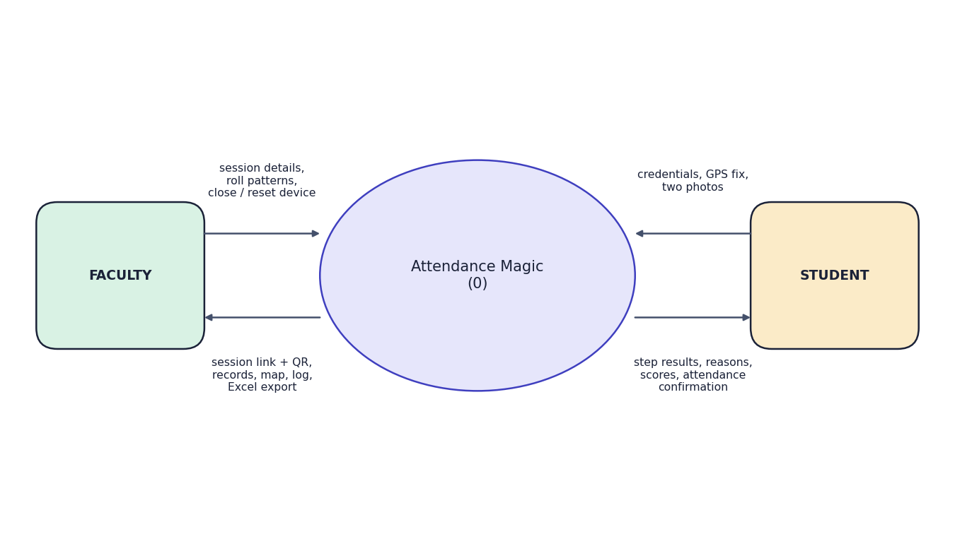
Fig. 1: Data-flow diagram, level 0 (context diagram)
The faculty member can create a time-bound session, set the geo-fence and roll patterns, share the link and QR code, view records, map, log and analytics, export to Excel, close a session or reset devices, and enrol a student's reference face. The student can register with a reference face, sign in with a device-bound token, pass the eligibility check, verify location, complete the random live challenge, pass face verification and view the result. Every student step is logged in verification_attempts.
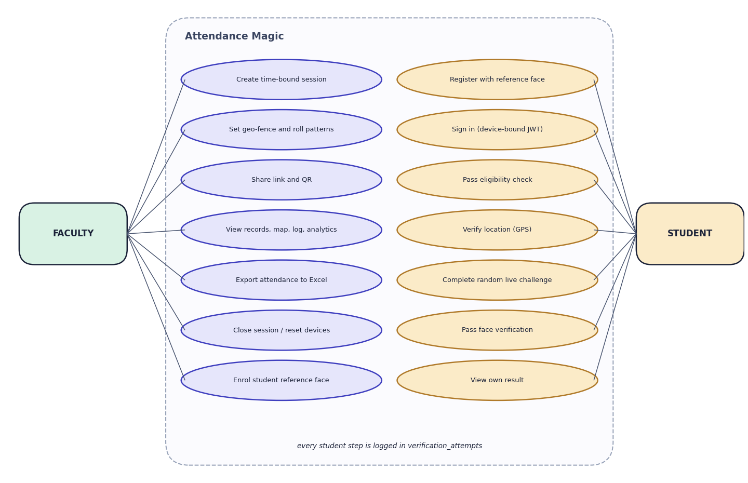
Fig. 2: Use-case diagram

3 Limitations and Assumptions
The limitations below are real and are repeated in the results and conclusion chapters; none is hidden by the numbers quoted elsewhere.
- No live-camera or volunteer trial. All photographs used in evaluation are still images from the public LFW benchmark (and a demo set of stand-in photographs). The genuine pass rate of each live challenge and the retake rate for real selfies were not measured.
- Liveness is the weakest link. A single photo rotated by 15 degrees or more passes both tilt challenges (98-99%). An attacker holding several photos of the victim passes the full chain 95% of the time for a head-turn challenge and 49% for open mouth (LFW identities with 10 or more photos, so an upper bound for ordinary students).
- Single-face rule. 15.7% of LFW photos (1,208 of 7,701) are rejected by the rule that exactly one face is allowed (almost all as 'more than one face'). LFW crops are tight and low resolution, so selfie behaviour may differ.
- Neutral frame strictness. Only 32.9% of LFW press photos satisfy the neutral-frame check (|yaw| <= 0.10, mouth closed, one face); students are instructed to look straight, so acceptance should be higher, but was not measured.
- GPS. Real phone GPS error and indoor drift were not measured (a simulation is reported); fake-location apps are not detected; the default tolerance is 15 m.
- Scale. One uvicorn process and SQLite; no load test. Model inference runs on the CPU at about 0.18 s per face.
- Security hardening. The default JWT secret is a placeholder, passwords have no lockout, and camera and GPS on phones need HTTPS, which was not set up.
- Project definition versus build. The abstract mentioned Django REST Framework and PostgreSQL on Supabase; the implementation uses FastAPI and SQLite (PostgreSQL by configuration, untested).

4 Advantages and Constraints
Table 1: Advantages and constraints
Advantages | Constraints
No new hardware; runs on phones and a laptop | Camera and GPS on phones need HTTPS
Free software end to end; offline operation | Single-process SQLite deployment; no load test
Six independent checks, each logged with a reason | Liveness can be beaten by rotated photos and photo banks
Pre-trained models need no training data | Models are used as published; thresholds tuned only by measurement
One shared service layer for two interfaces | GPS accuracy, indoor drift and mock-location apps not handled

5 Limits of the Testing Done
- All face photographs are still images from LFW or stand-ins for student photographs; no live camera, phone browser or human volunteer was involved.
- The challenge photo in the automated flows is either a real second photograph that satisfies the issued challenge or a rotated copy for the tilt challenges; this exercises the logic but is not the same as a person performing the action.
- GPS positions are supplied by the test (or by the browser's emulated geolocation); real phone GPS behaviour was not measured.
- No load, stress, soak or penetration testing was done; the tests run in one process on one machine.
- Coverage was not measured with a coverage tool; the 23 tests concentrate on core/, and the React interface has no automated unit tests.

6 Limitations of the Results
- LFW photographs are news images, not selfies; the single-face and frontal-pose rates on student phone photographs are unknown.
- No live person performed any challenge. The genuine pass rate of each challenge, the time to complete a check-in and the number of retakes were not measured.
- The photo-bank attack uses public figures with many photographs; it is an upper bound for ordinary students.
- The GPS results are a simulation under an assumed noise model.
- Timings come from one machine that was running other applications; they are indicative.
- The comparison with the base paper is qualitative because its data, size and protocol are not given.

